PAGE1:homepage(homepage3 mockup)

Main page:1

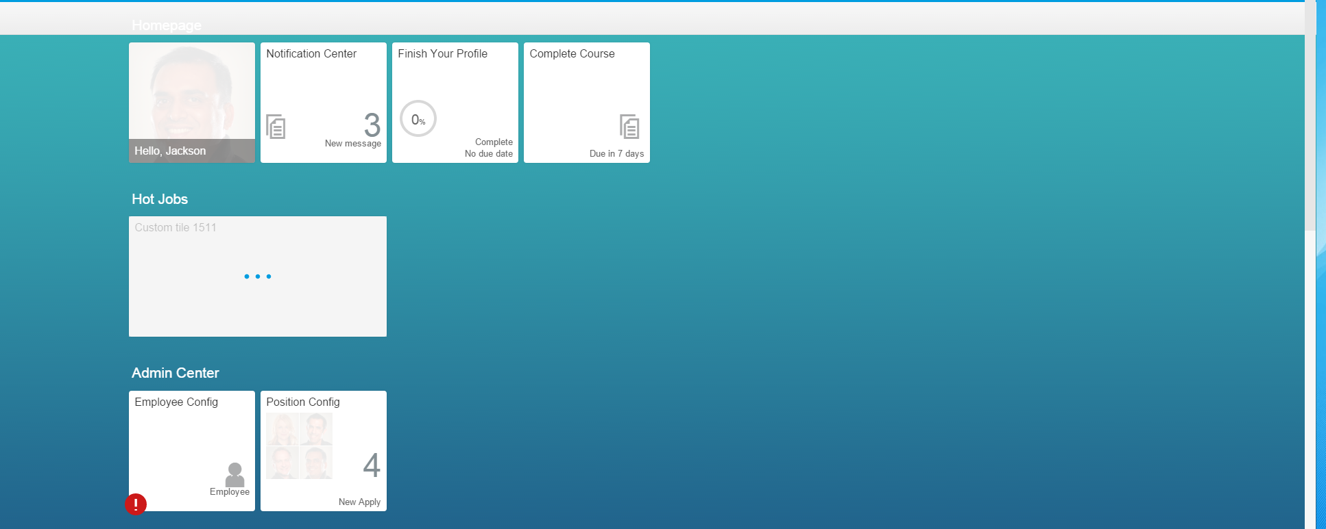

PAGE2:course(list)

Main page:1; subpage:3( todo, done, overdo); courseDetailpage:1

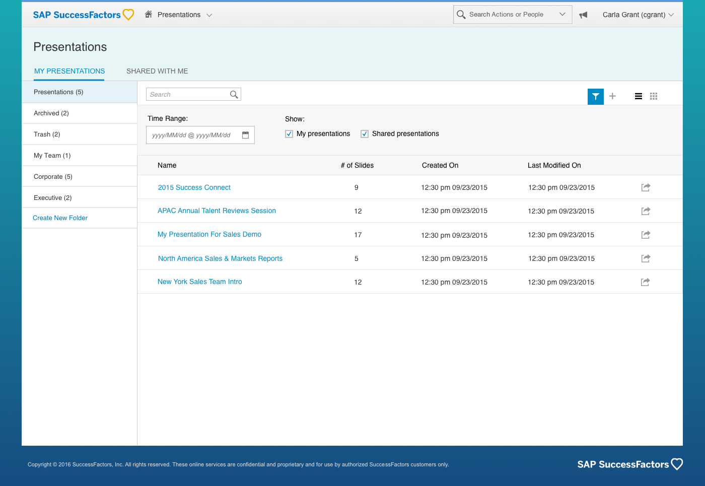

PAGE3:position( presentationlist; apply position: popup)

Main page:1; subpage:2( new job, applied); popup dialog:1

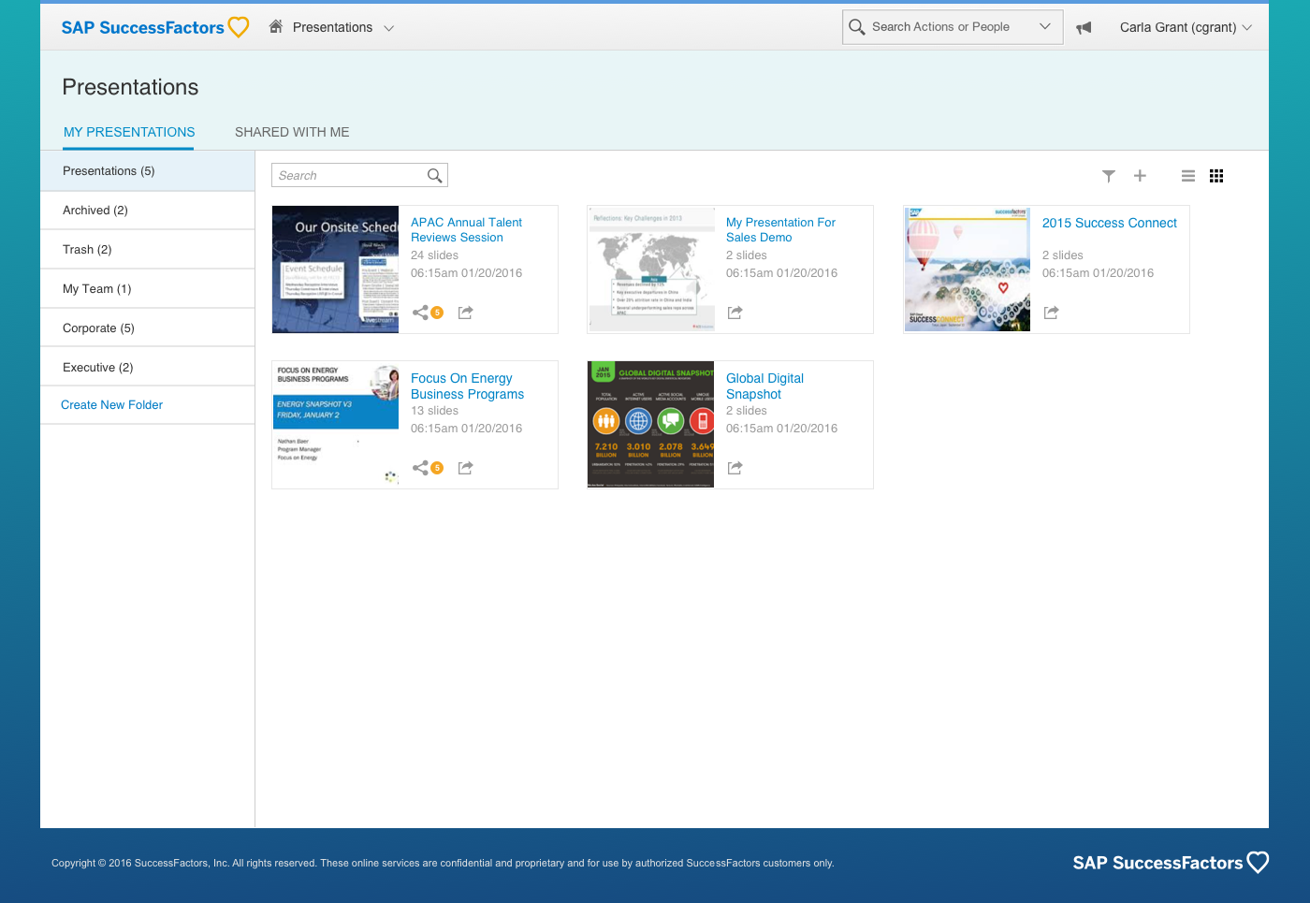

PAGE4: orgchart(3 layer)

Main page:1

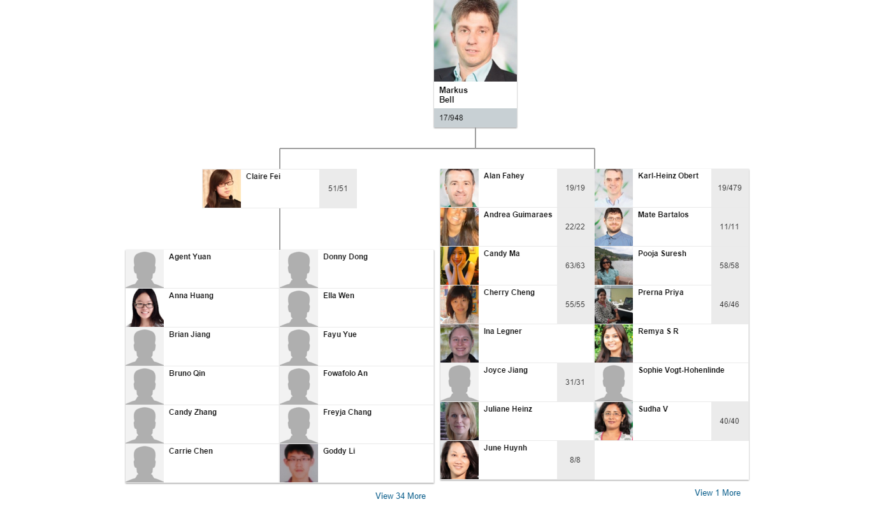

PAGE5: admin( emp ADIS; position; course)

Main page:3

PAGE6: emp info minicard

Main page:1

